
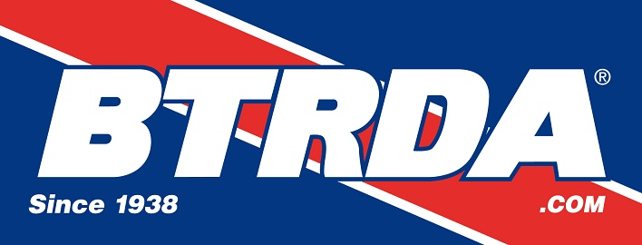
MDA/Blyton Park Rallycross Test Day
Blyton Park, Sunday 28th February 2016

Official Entry Form

Main Driver Name …......................................................

Address …...........................................................................................
…............................................................................................
…............................................................................................
Post code …..................

Telephone ….................................... Mobile ….........................................

Email Address …...........................................................................................

Additional Driver Name …......................................................

Address …...........................................................................................
…............................................................................................
…............................................................................................
Post code …..................

Vehicle Make/Model …................................................ Engine CC …...................

Class Entered …................................... Championship Race No' ….................

Licence Number …................................. Transponder Number ….....................

Next of Kin details (Name and Telephone Number)

…............................................................. Tel …....................................

ENTRY FORMS AND PAYMENT MUST BE RECEIVED AT LEAST 2 WEEKS PRIOR TO THE EVENT (February 14th)

Entry Fee £120.00 per Car + £30.00 Extra Driver (Max 2 drivers)

Entry forms to be returned to :
Sam O’Flanagan, 1 Godlings Way, Braintree, Essex, CM7 1HW
(please ensure all parts of form are completed)

Cheques to be payable to: “Minicross Drivers' Association Ltd”

Bank Transfers can be made to Minicross Driver's Associaton account
Sort Code 09-01-27 Account Number 77354899 – if paying by bank transfer make sure you note the payment date on this form and the account name if different to the driver/entrant name.

Entry forms can also be e mailed to the event secretary at; entries@mini-cross.co.uk

** PLEASE ENSURE THAT YOU HAVE READ AND SIGNED THE DECLARATION ON THE BOTTOM OF THIS FORM **

Indemnities Declarations & Undertakings by Drivers

I declare that I agree to be bound by any Regulations or Final Instructions issued by the Club. I declare that I am physically and mentally fit and competent to take part in the event. I understand that motorsport is dangerous and accidents causing death, injury, disability and property damage can, and do, happen. I understand that these risks may give rise to my suffering personal injury or other loss and I acknowledge and accept these risks.

In consideration of the acceptance of this entry I agree that neither any one of or any combination of the MDA, the organisers, the track owners or other occupiers, the promoters and their respective officers, servants, representatives and agents (The “Parties”) shall have any liability for loss or damage which may be sustained or incurred by me as a result of participation in the Event. Nothing in this clause is intended or shall be deemed to exclude or limit liability for death or personal injury. To the fullest extent permitted by law I agree to indemnify and hold harmless each of the Parties in respect of any loss or damage whatsoever and howsoever arising from my participation in the Event.

I declare that to the best of my belief the driver possesses the standard of competence necessary for an event of the type to which this entry relates and that the vehicle entered is suitable and roadworthy for the event, having regard to the course and the speeds which will be reached.

I understand that should I, at the time of the event, be suffering from any disability, whether permanent or temporary, which is likely to affect prejudicially my normal control of my vehicle.

Drivers signature : ….....................................................

PADDOCK SPACE AT BLYTON IS LIMITED – IF YOU NEED SPACE FOR A LARGE VEHICLE OR AWNING PLEASE GIVE DETAILS BELOW TO HELP WITH THE PADDOCK PLAN

…...........................................................................................................................................................................

…...........................................................................................................................................................................

